COMP S350F Software Engineering-record system(Testing plan report)

Group 16

Chan Tsz Yin, 13398567

Lee Chun Yin, 13360891

Free rider(Disappear) Chan Wai Shing

**1.Introduction**

The goal of this testing plan report is to offer an overview of the academic record system's testing strategy, objectives, scope, and schedule.

**2.Testing Objective**

* Verify that the web application's essential features are operating as intended.
* Determine and report any flaws or problems that are discovered during testing.
* Verify if the application satisfies the prerequisites.
* Check that the application works with various browsers and devices.
* Examine the application's stability and performance under typical load scenarios.

**3.Testing Scope**

The testing will cover the following areas of the application:

* User login.
* User profile management.
* Data input and validation.
* Data retrieval and display.

**4.Testing Approach**

**A. Validation test**

i. To demonstrate to the developer and the system customer that the software meets its requirements

ii. A successful test shows that the system operates as intended.

**b. Defect testing**

i. To discover faults or defects in the software where its behavior is incorrect or not in conformance with its specification

ii. A successful test is a test that makes the system perform incorrectly, and so exposes a defect in the system,

**5.Testing Schedule:**

The testing activities will be conducted according to the following schedule:

* Test Planning: [15 Oct ] - [30 Oct]
* Test Case Preparation: [15 Oct] - [9 Dec]
* Test Execution: [15 Oct] - [9 Dec]
* Defect Reporting and Tracking:[1 Dec] - [10 Dec]
* Test Closure and Report Generation: [10 Dec]

**6.Test Deliverables:**

The following test deliverables will be produced during the testing phase:

Test Plan: Outlining the testing approach, objectives, and scope.

Test Cases: Detailed test cases covering various scenarios.

Test Data: Required data for executing the test cases.

Defect Reports: Documenting identified defects, their severity, and priority.

**7.Testing Environment:**

The testing environment for the Academic record system includes:

Operating System: Windows 11

Browsers: Edge

Devices: Desktop

Test Management Tool: [Visual Studio code]

**8.Test result**

**A.Validation test**

**Test case1: Login**

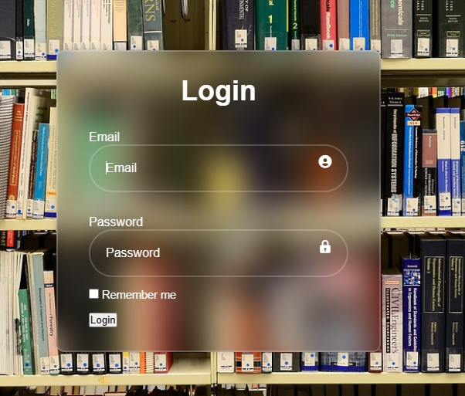

This is the first page of our system. The user needs to login before using the system. When you input the correct email and password, the window will tell you successful login and move to the main page.

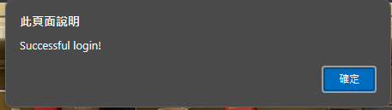

Otherwise, if the email or password was wrong, the window will say Invalid credentials. The user cannot login to the system.

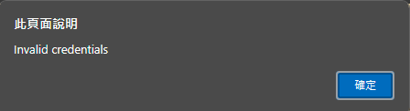

**Test case2: Record**

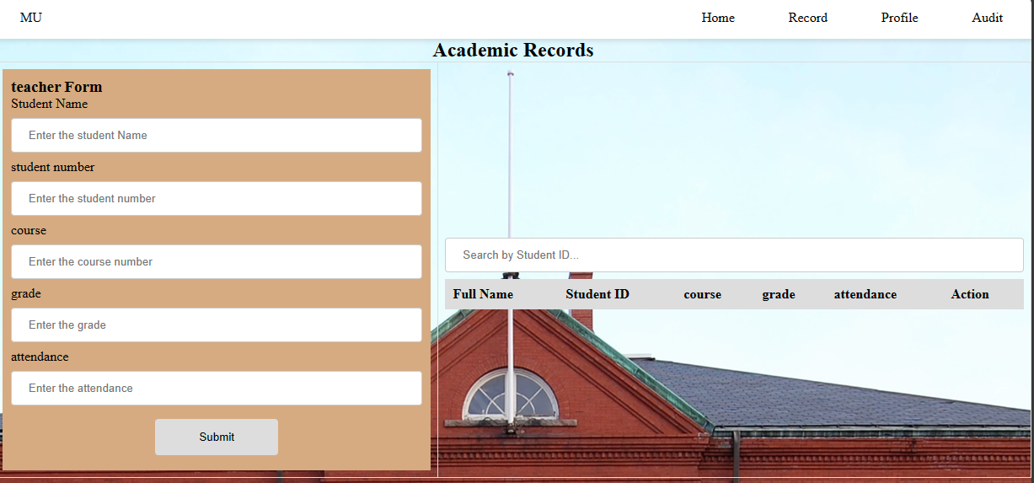

Our second function is to view and update a students’ academic record. The teacher can click the “Record” on the main page. Here are 5 inputs for teachers to save the student record(Student Name, Student number, course, grade and attendance).

THE OUTPUT: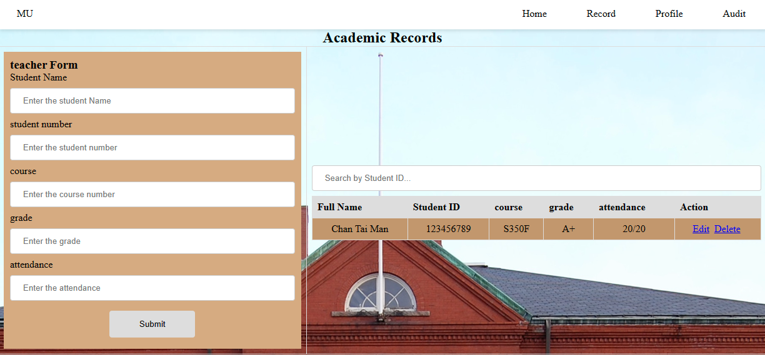

After inputting the records, the student data will show on the right side. If the teacher wants to edit the record or delete the data. He can click the Edit or Delete.

**Test case3 :Profile**

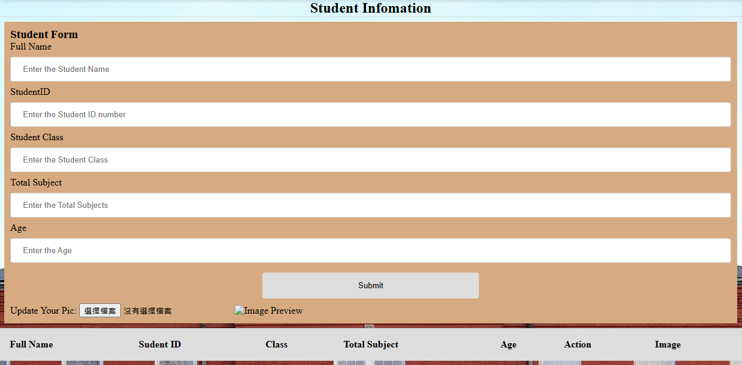

It also is a record function. Students can update their information(Name ,StudentID, Class, Total Subject and Age). They can edit their information.

THE OUTPUT:

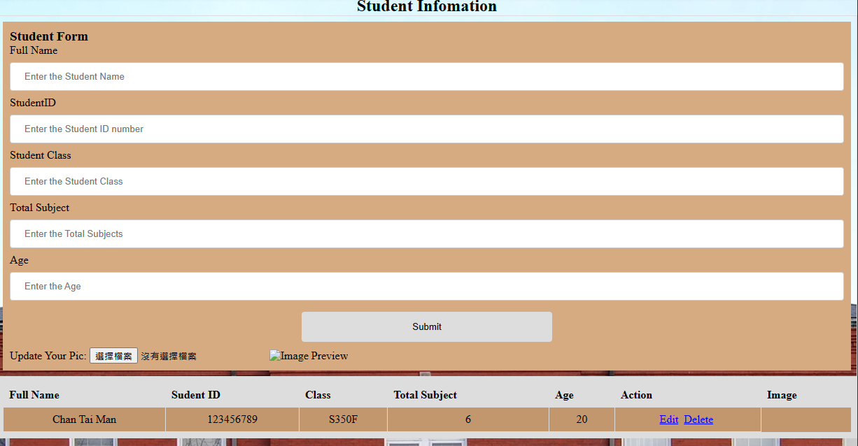

**2.Defect testing**

**Test case1 :Authentication(failure)**

Description: we can’t make this function because the language does not support it.

Steps:

Expected results:The system should provide secure login functionality to ensure that only authorized users can access and modify the records.

**Test case2: Search bar(error)**

Description: When typing in the search bar, the data will not arrange.

Steps:

1. Teacher enter the academic record

2. To find the student in search bar

3. Do not have any action

Expected results: Teacher can find the student by student ID from the student entered information in the search bar

**Test case3: Data Backup(failure)**

Description:There are records after typing in the academic information but the records cannot save after reopening or refreshing the page.

Steps:

1.Teacher enter the academic record

2. The record will show out

3. After refreshing the page, the record will disappear

Expected results:Regular data backups should be performed to prevent data loss and enable recovery in case of any system failures or data corruption.

**Test case4: Audit trail(failure)**

Description:According to the failure of data backup, the audit trail is not working as well.

Steps:

1.Student or teacher enter the data

2.teacher can view the audit trail to know who edited the data

Expected results:The system should maintain an audit trail, recording any changes made to the student records, including details of who made the changes and when.